1. ps – Report a snapshot of current processes 1. How would you use ps to display all processes running on the system, not just those owned by the current user?

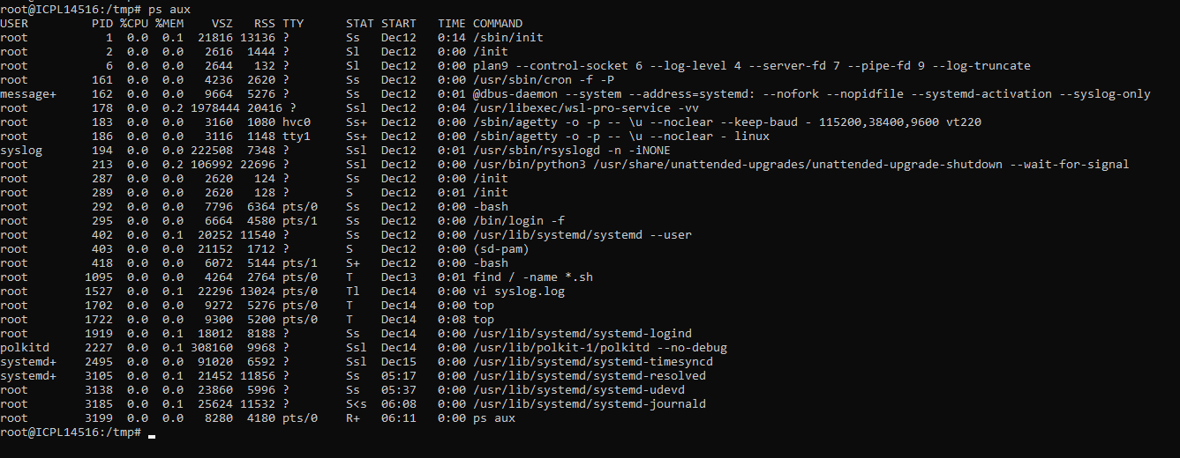  
2. What is the difference between ps -e , ps -f , and ps -ef ? Provide examples. ps -e : Displays all processes. ps -f : Provides a full-format listing with additional details. ps -ef : Combines both to show all processes in full format.  
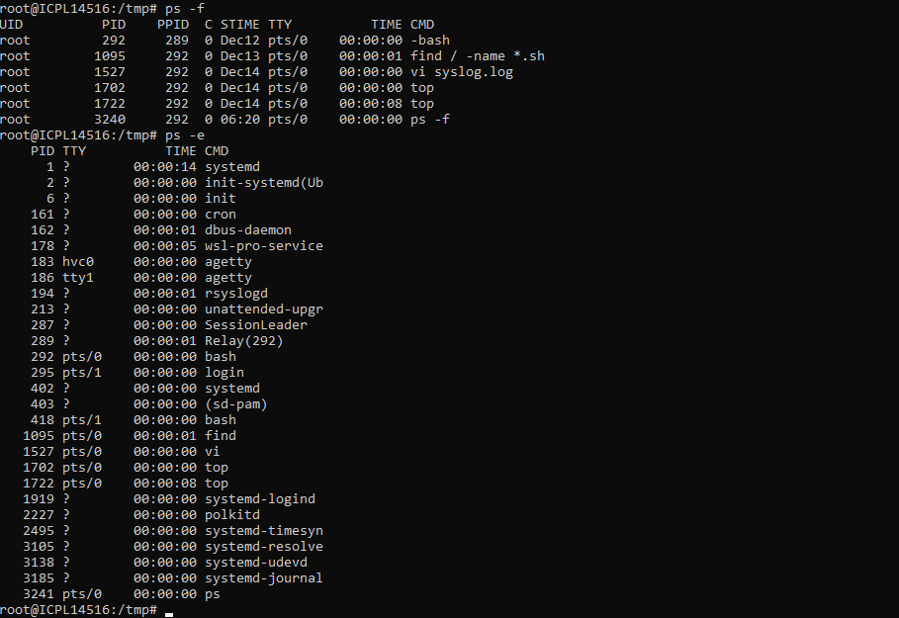  
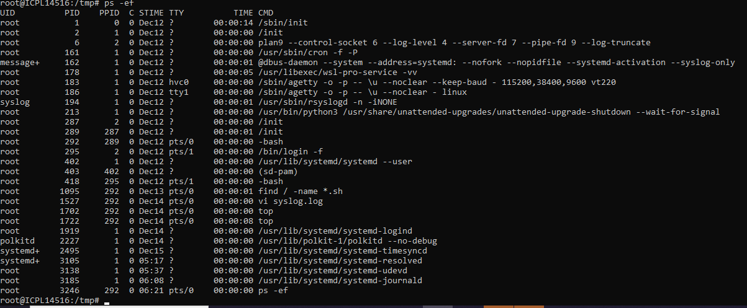  
3. How can you use ps to find the PID of a specific process (e.g., nginx )? Use the grep command with ps :  
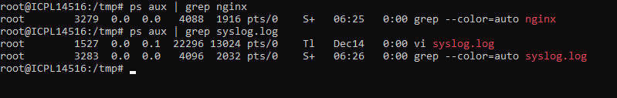4. How can you display hierarchical information about parent and child processes using ps ? Use the ps --forest option (or --ppid for specific parent PIDs):  
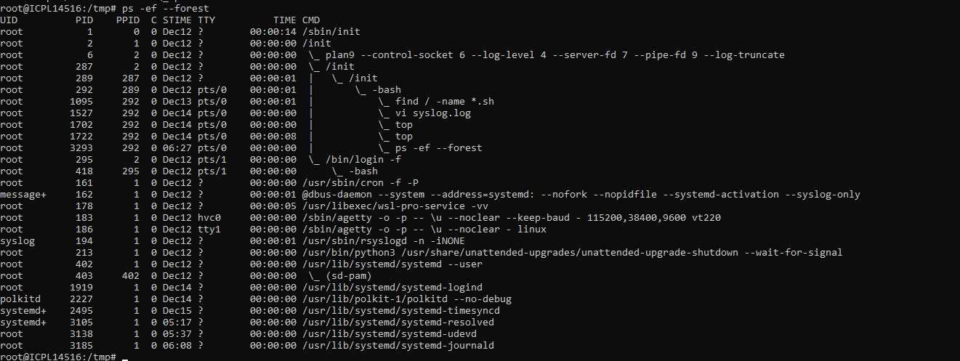5. What is the difference between top and htop ? Why might you prefer one over the other? ***top is a standard CLI tool but lacks interactivity. htop is more user-friendly with an interactive interface for killing processes, filtering, and sorting.***  
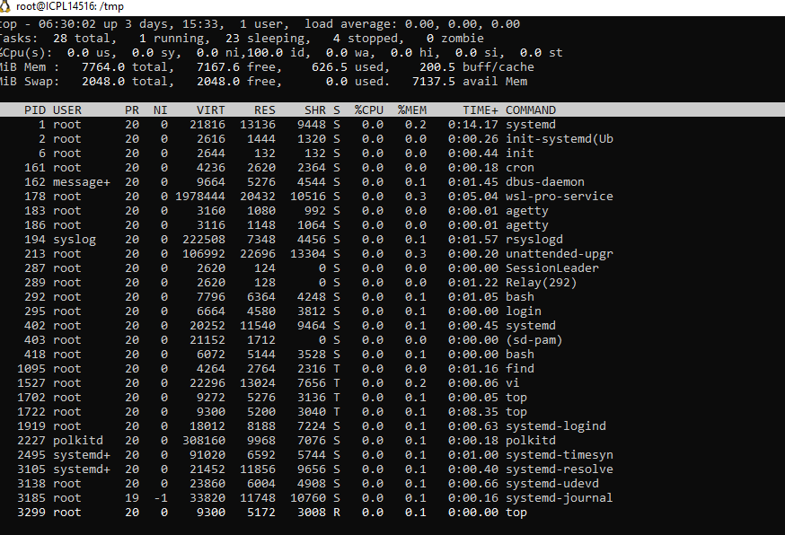  
6. How can you sort the output of top by memory usage instead of CPU usage? While in top , press M to sort by memory.  
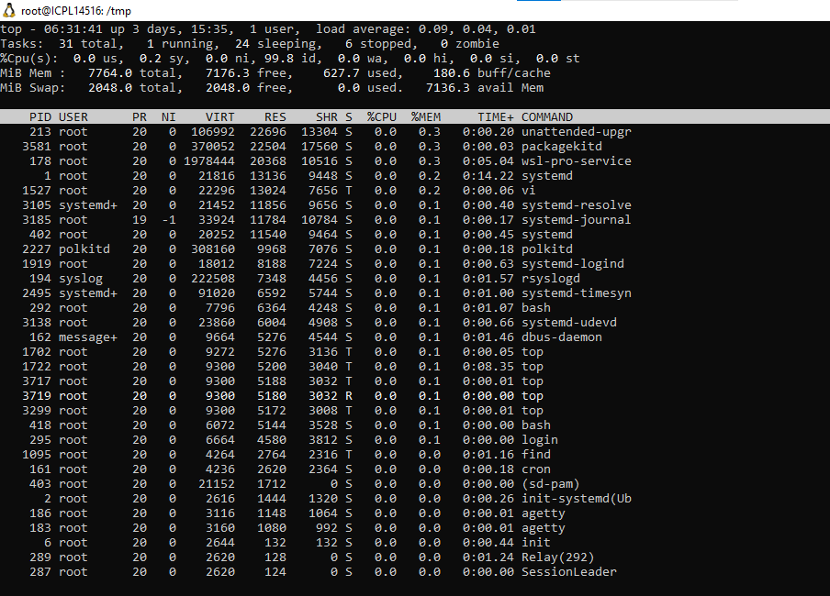

File and Directory Management  
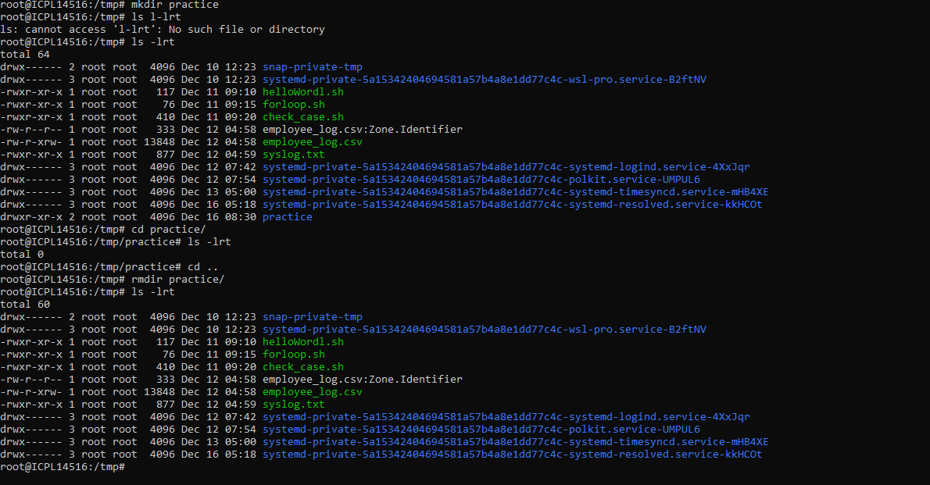

Process Management  
  
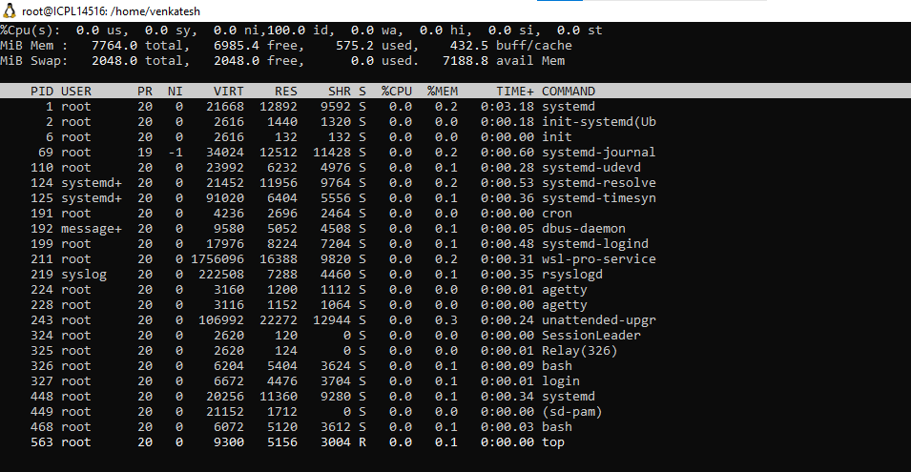

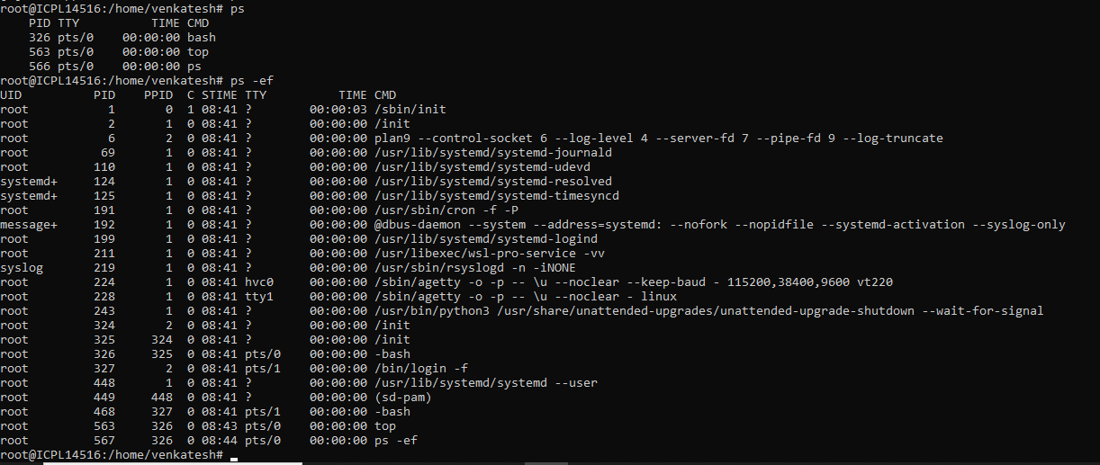

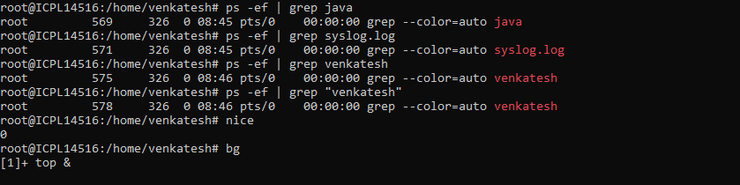  
  
Network and Connectivity  
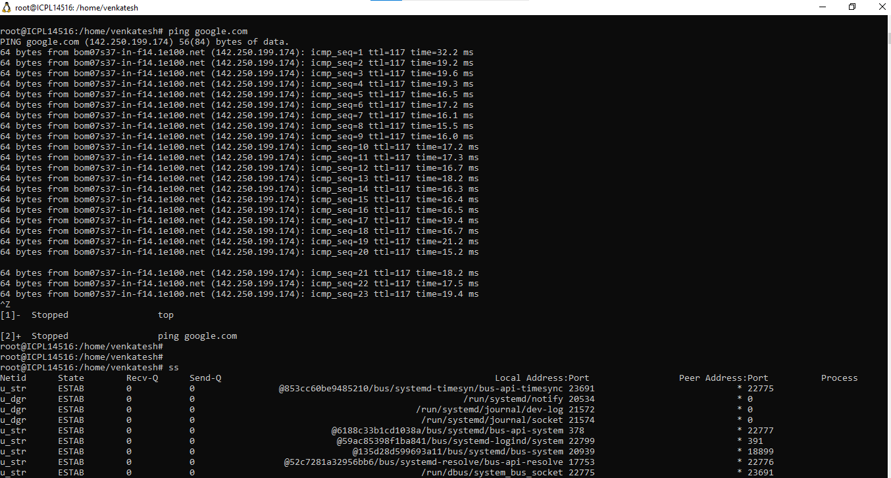  
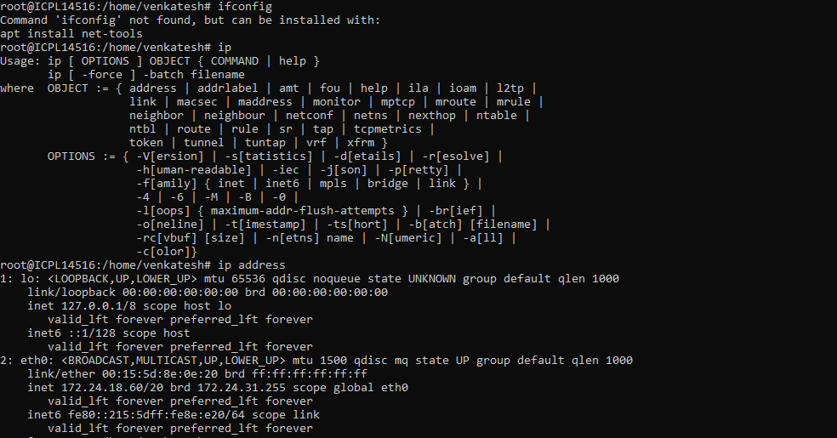  
System Monitoring and Diagnostics   
  
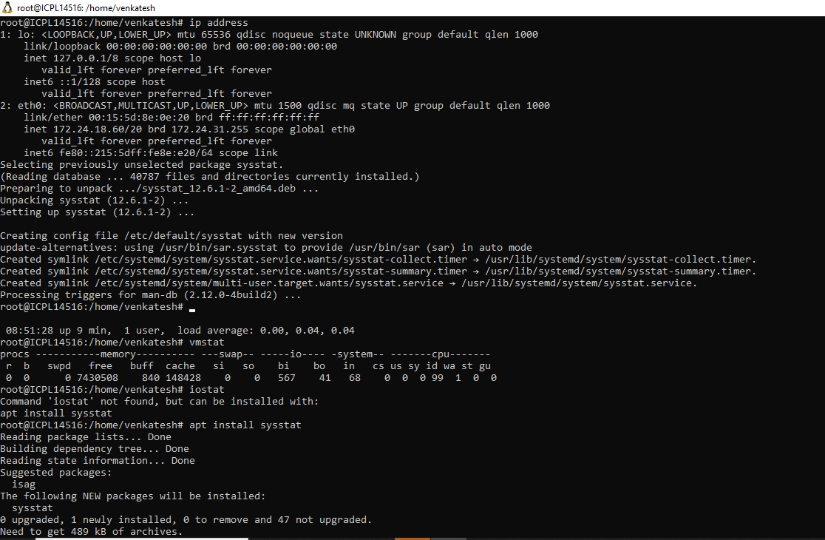  
  
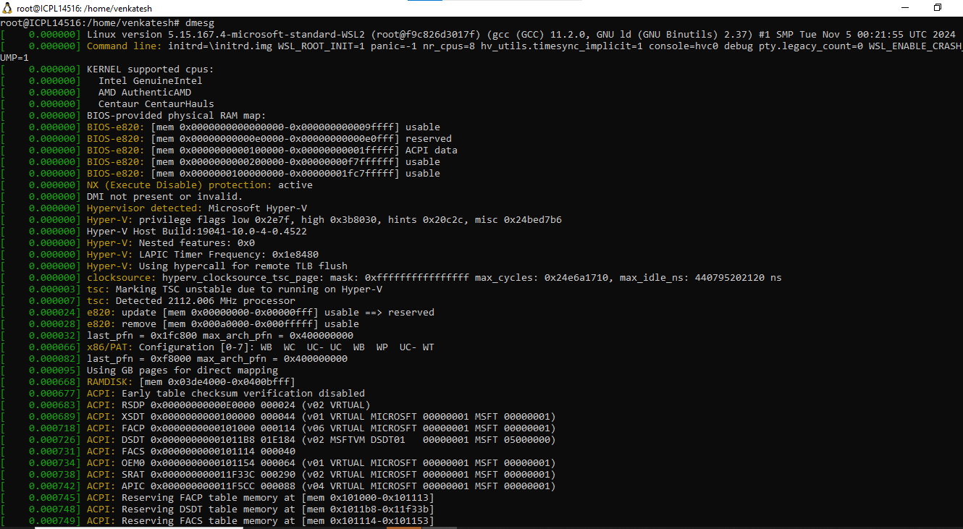

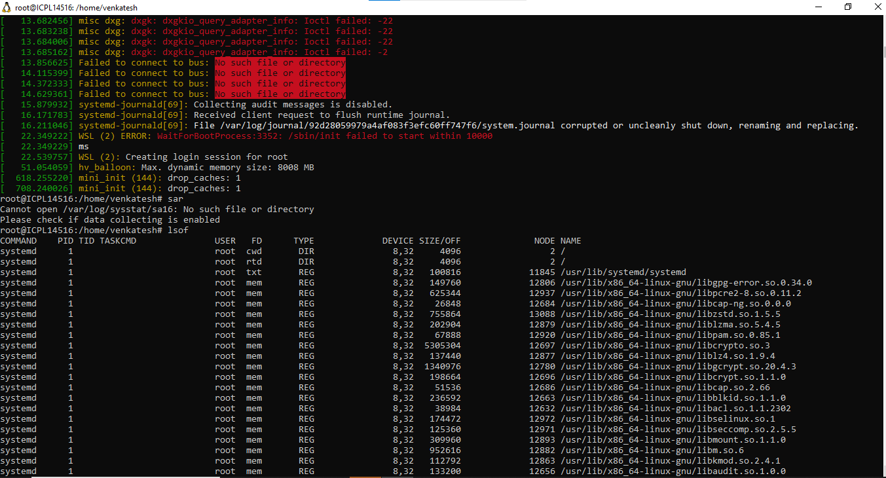  
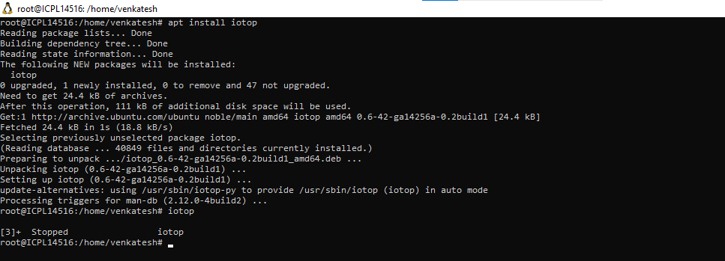  
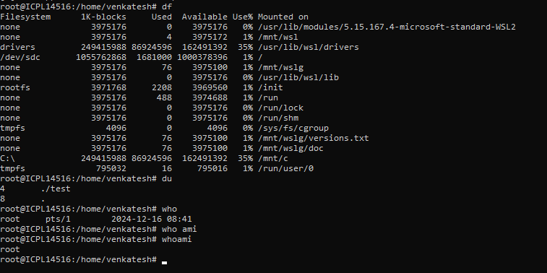

Log Management  
  
